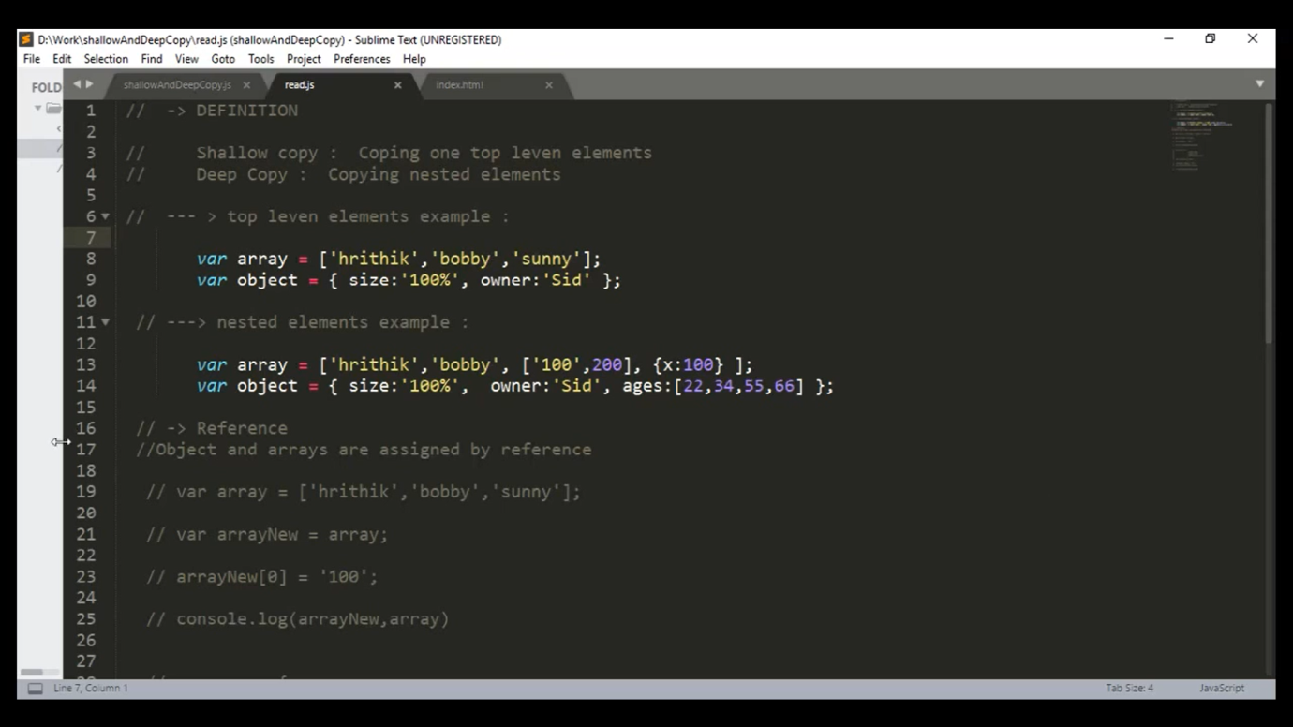  
A deep copy means that all of the values of the new variable are copied and disconnected from the original variable. A shallow copy means that certain (sub-)values are still connected to the original variable

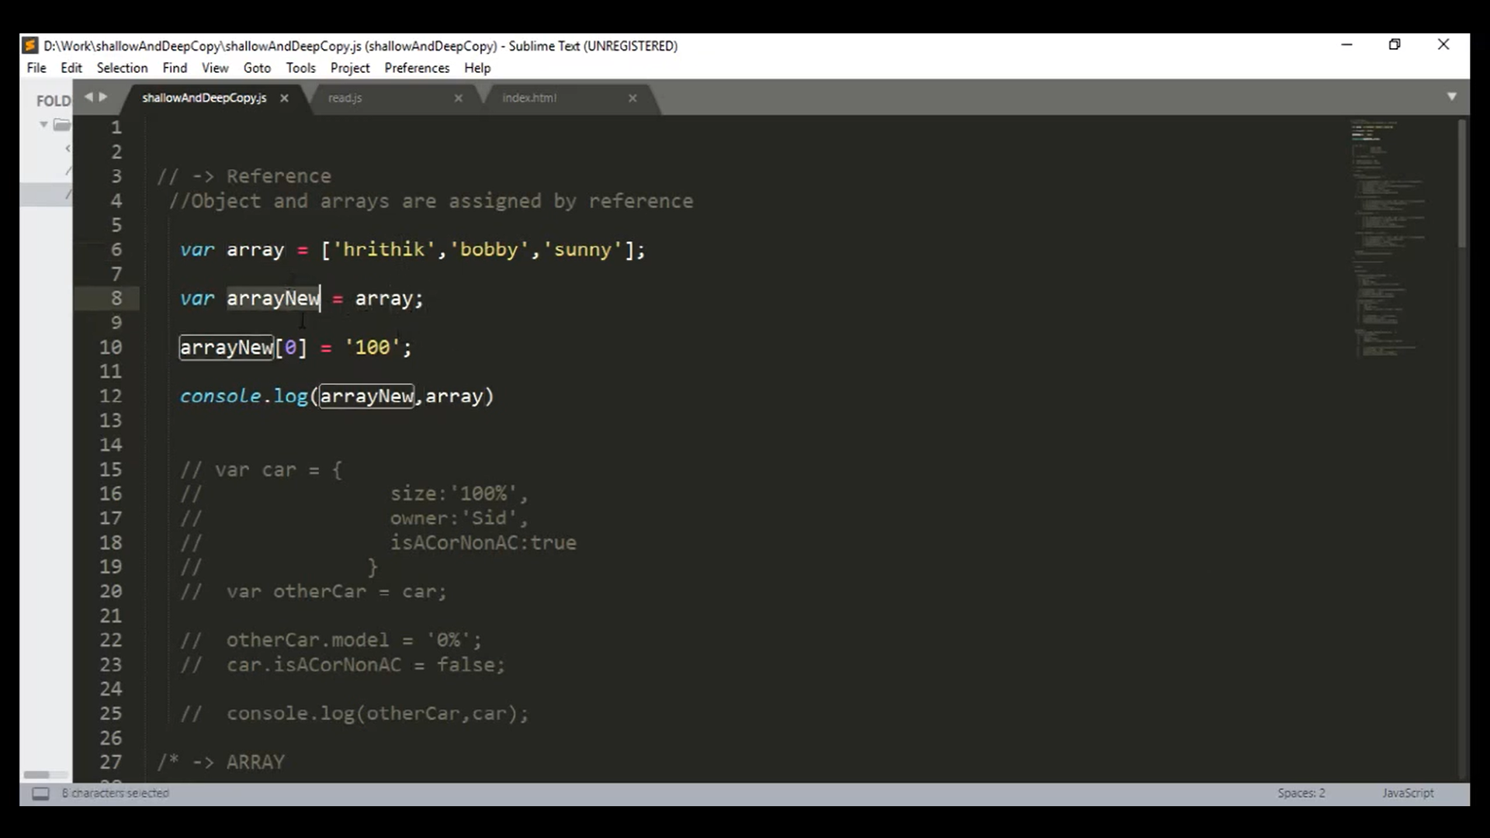

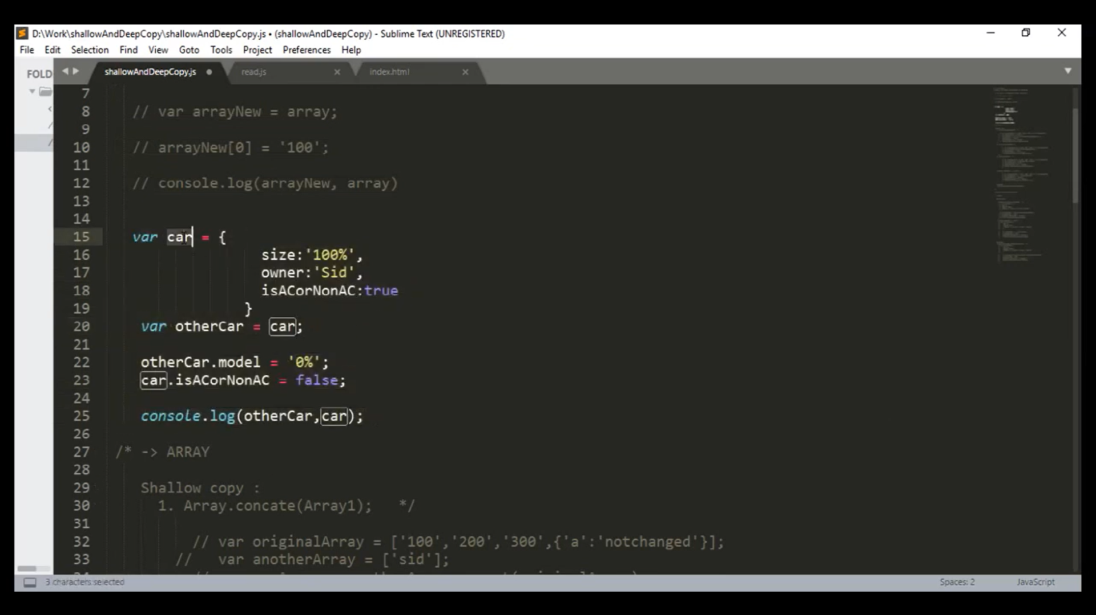

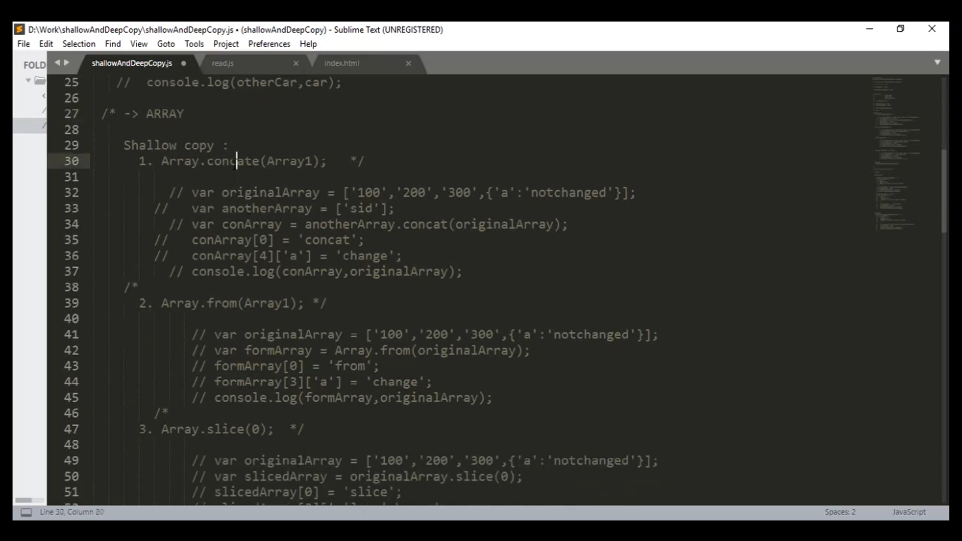

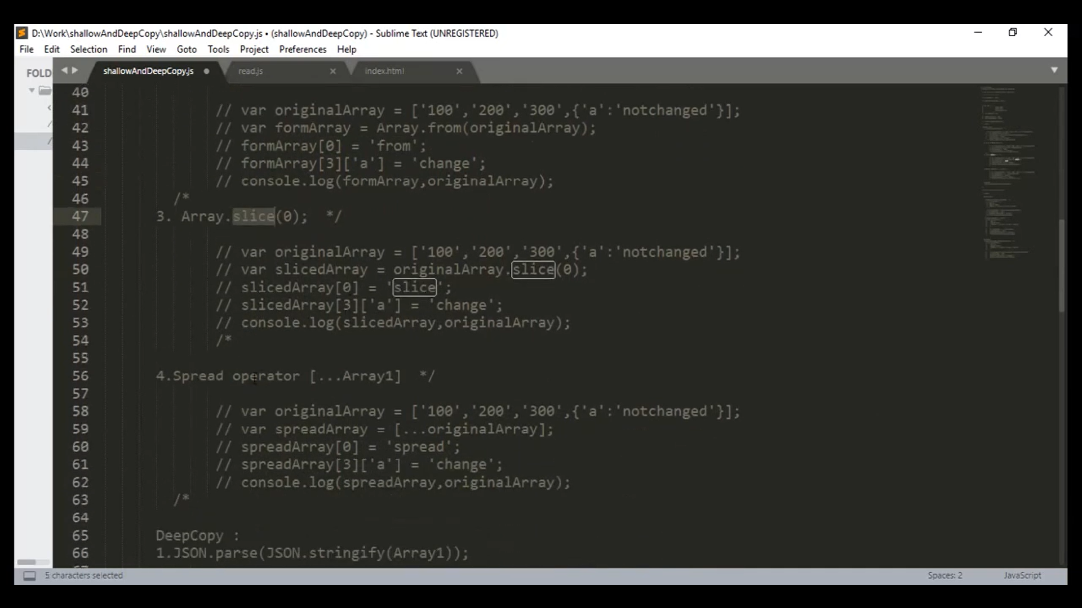

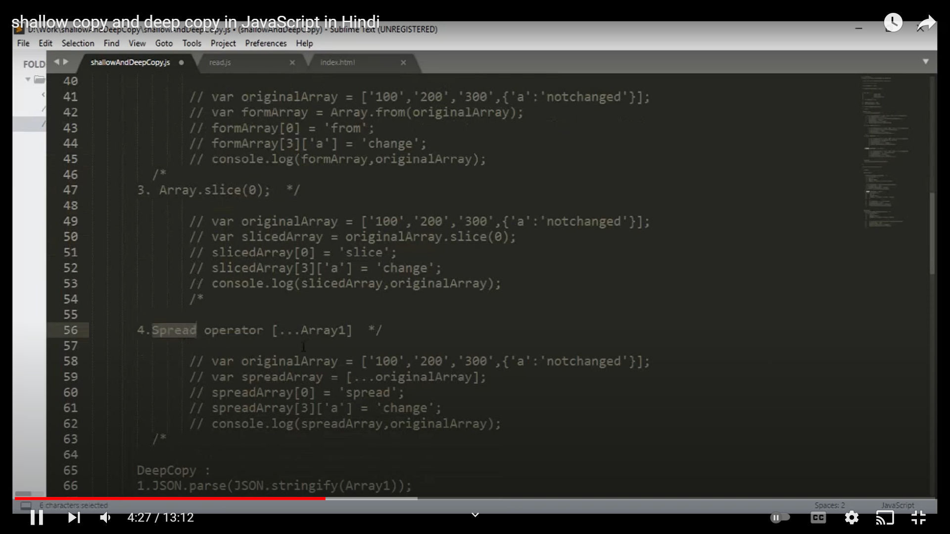

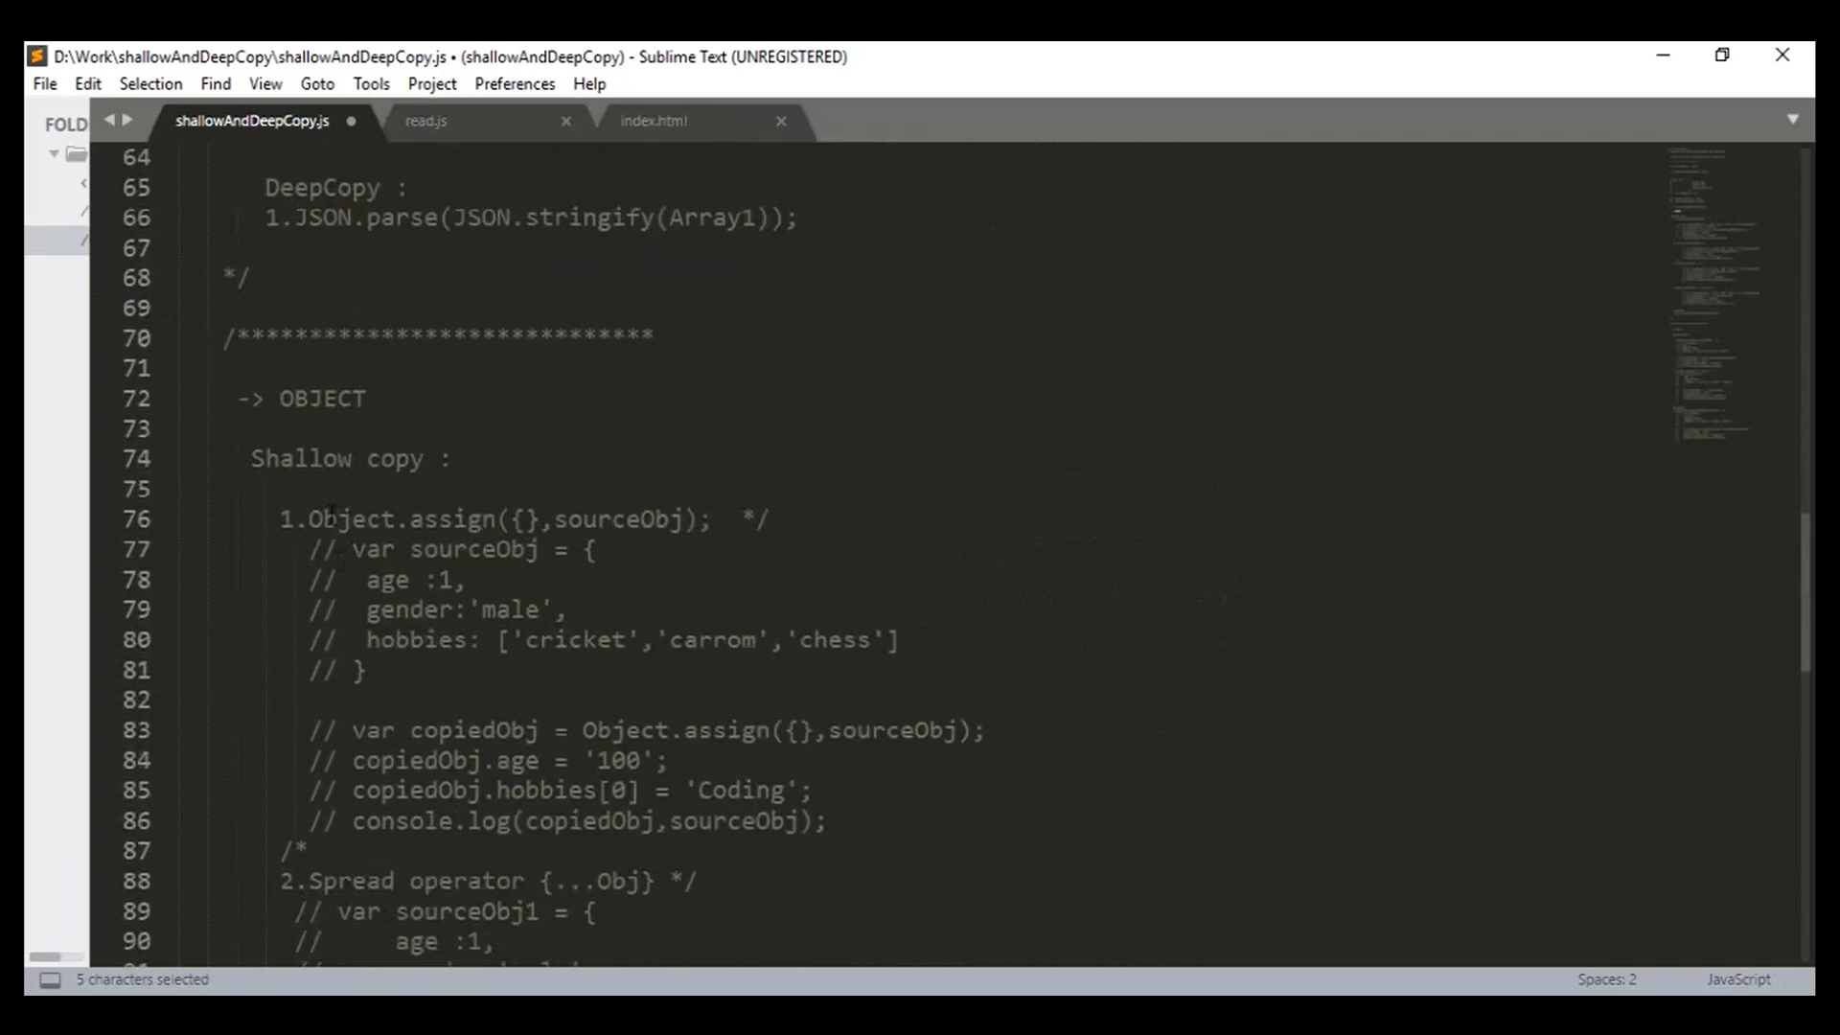

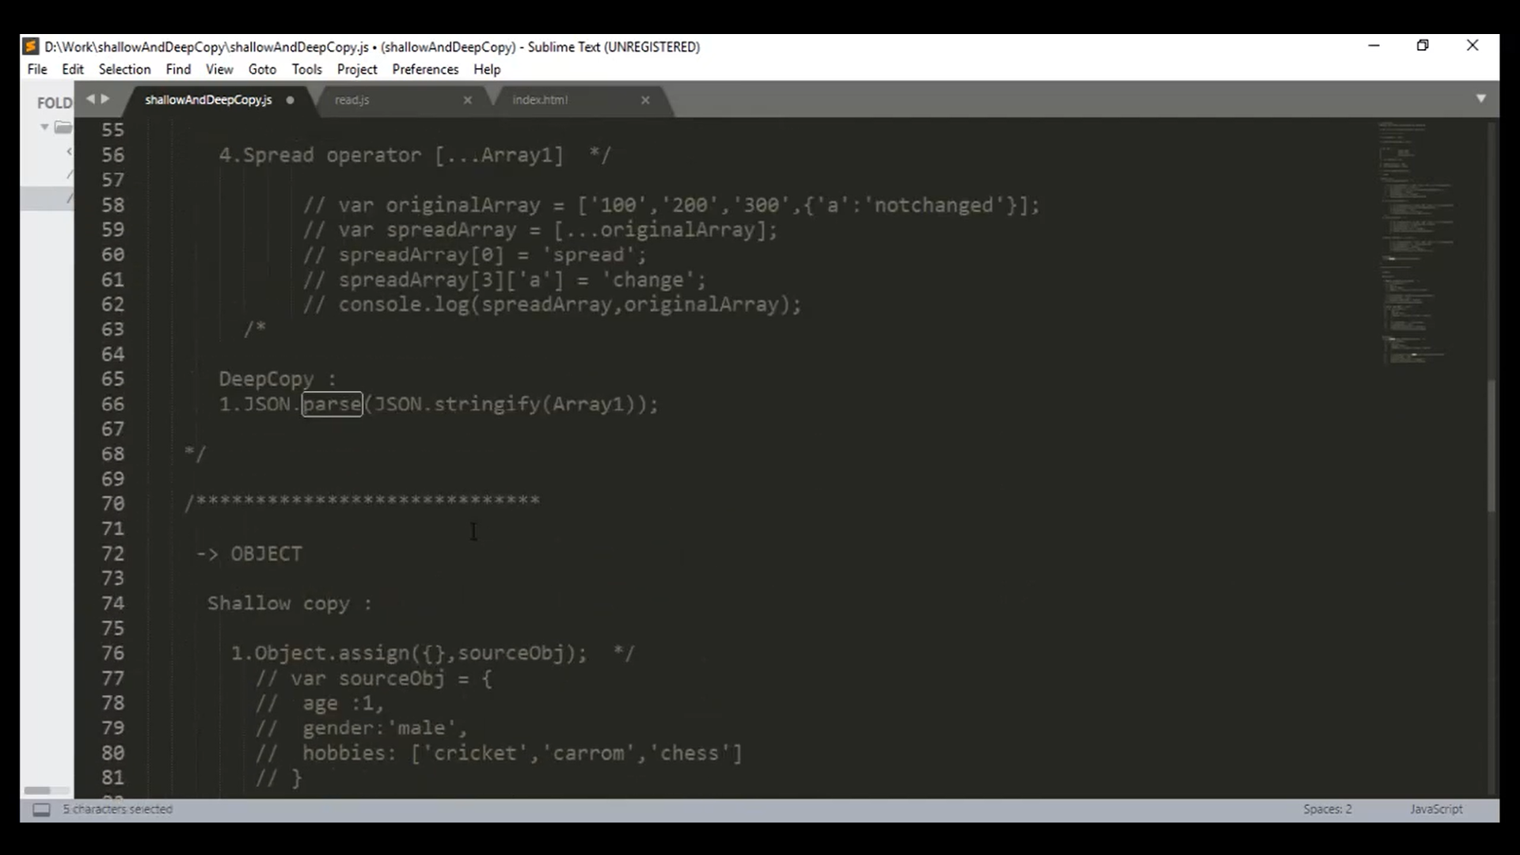

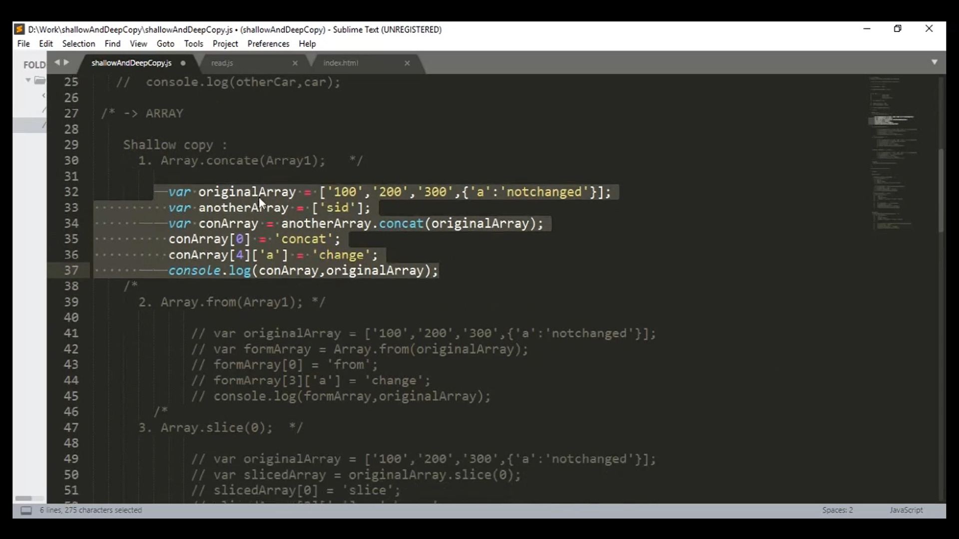

Shallow Copy

 <script>

      var a = [100,200,300,{a:'india'}];

      var b =[1000];

      var c = a.concat(b);

      console.log(a);

      console.log(b);

      console.log(c);

      c[0] = 100000000;

      console.log(a);

      console.log(b);

      console.log(c);

      c[3][a]=200000000000000000;

      console.log(a);

      console.log(b);

      console.log(c);



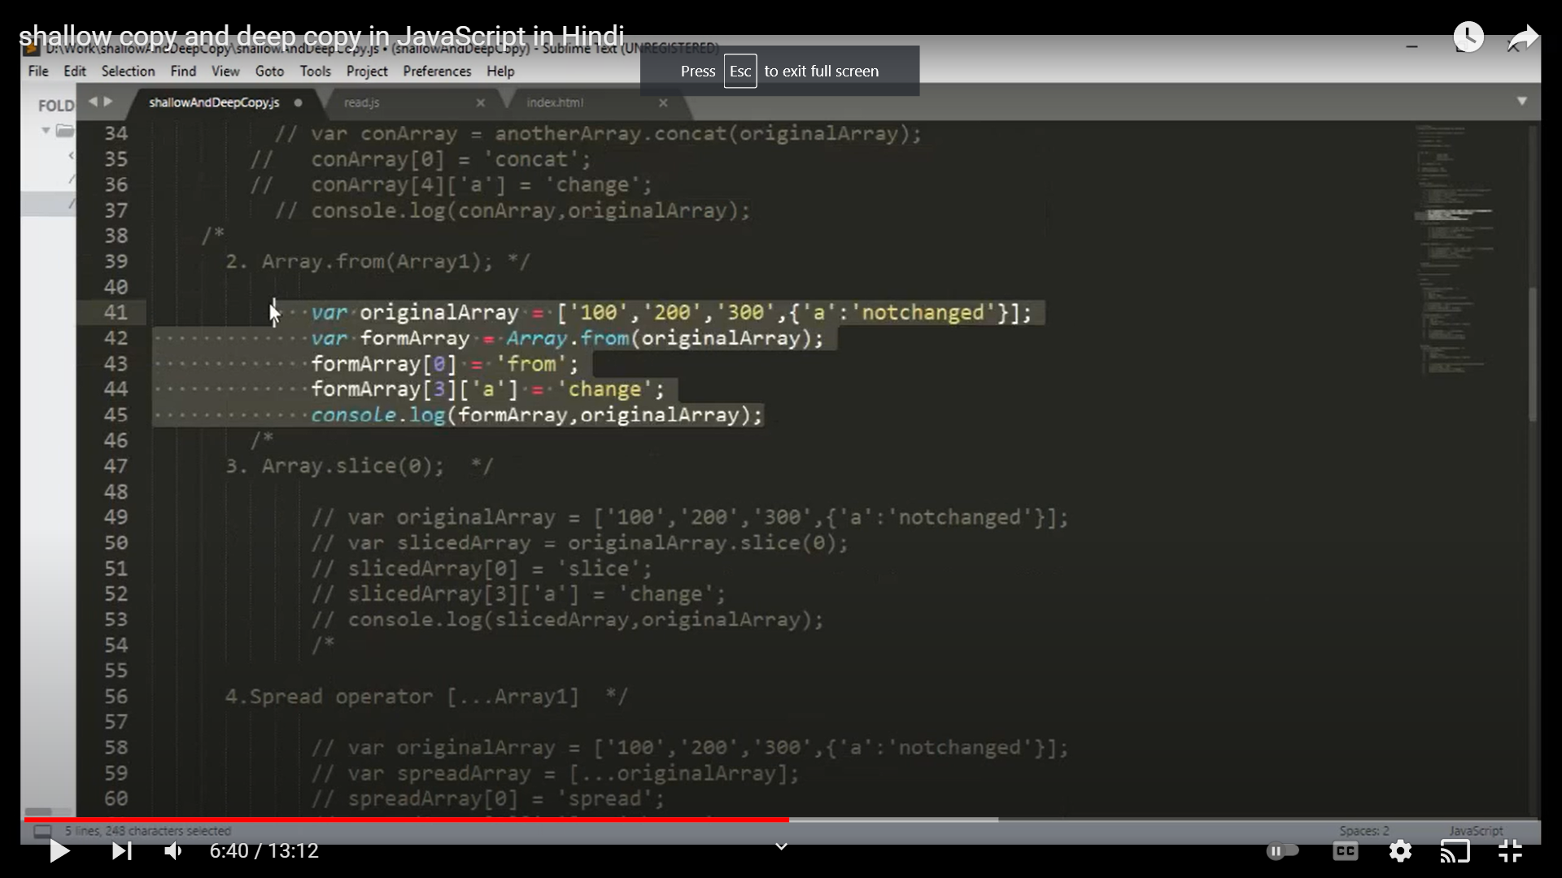

* Object

Shallow Copy

1. Object.Assign({} , source);
2. Spread Operator

Deep Copy

JSON.parse(json.stringyfy(Array1))